CSC 330 – Artificial Intelligence

**Homework Assignment #3 – Game-Playing Algorithms**

## Due on Friday, February 21, by the beginning of class

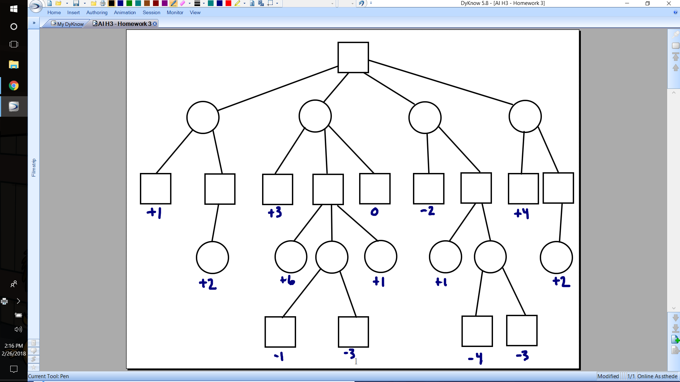

Show the results of running the ALPHA-BETA algorithm on this tree. Assume nodes are considered from left-to-right. **Clearly** label each node with its v, α, and β values, and **clearly** label each node that is pruned from the search tree.

